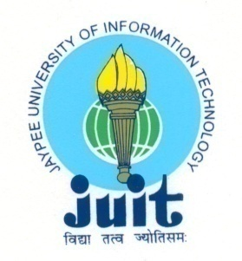 | JAYPEE UNIVERSITY OF INFORMATION TECHNOLOGY  (Established by H.P.State Legislative vide Act No. 14 of 2002)  Waknaghat, P.O. Dumehar Bani, Kandaghat, Distt. Solan – 173234 (H.P.) INDIA  Website :www.juit.ac.in  Phone No. (91) 01792-257999 (30 Lines)  Fax : (91) 01792 245362
NAAC Criteria Supporting Document
Criteria 4

4.1.2 Major Cultural Sports Motivational Activities

Criteria | Criterion IV – Infrastructure and Learning Resources
Key Indicator | 4.1 Physical Facilities
Metric | 4.1.2: The institution has adequate facilities for cultural activities, yoga, games and sports (indoor & outdoor); (gymnasium, yoga centre, auditorium, etc.,)

Additional Information

S. No. | Document Title | View Document
1 | Major Cultural Sports Motivational Activities
 | Major Cultural Sports Motivational Activities 2017-18 | View
 | Major Cultural Sports Motivational Activities 2018-19 | View
 | Major Cultural Sports Motivational Activities 2019-20 | View
 | Major Cultural Sports Motivational Activities 2020-21 | View
 | Major Cultural Sports Motivational Activities 2021-22 | View

